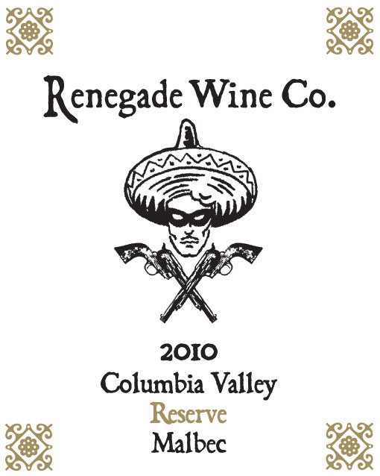

The 2010 Renegade Wine Co. Reserve Malbec is our newest entry into the “Reserve” lineup of wines for the Renegade Wine Company. The source for this Malbec is Stone Tree Vineyard, located on the Wahluke Slope above the Columbia River in central Washington State. The combination between the shallow soils, hot weather, tempered by the gusty winds, are known to produce tremendous wines of character. This Malbec is no different, with its inky purple color, and nose of infused pepper and plums, wrapped around a core of spicy acids and a kiss of new French oak. Sadly, only 2 barrels were produced, so if you are holding one of the bottles in your hand, I suggest you take it home…now! Be a Renegade!

